Presenting about an Economic Public Policy

Ops: Syria, Ukraine, Russia, (Afghanistan)

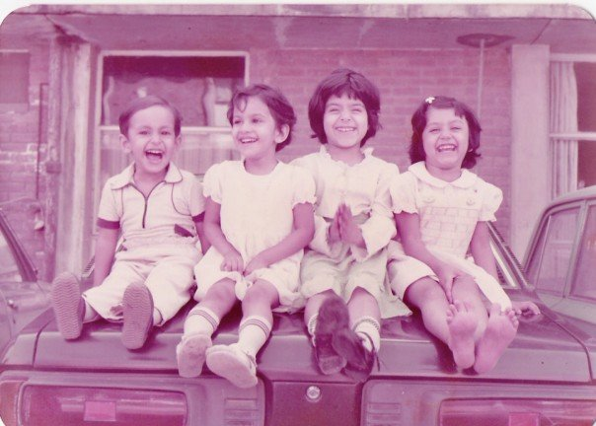me and my Girls, PAF Base CHAKLALA (Obama), PAK  
Learning, failing at Karate

Astute student, military strategy

Military brat, Pakistan Air Force

director, Flower Economics Inc.